**Workshop 3 Fast transient overvoltages: lightning surges**

Date: 2/12/2023

Name: Javier Muñoz Sáez

**3.1 Introduction**

We would like to simulate the effects of lightning strikes on a complex network. The image bellow is a scheme of a step-down power system of 35 km of length and compose of 2 power transformers. The end of this power system is in open-circuit.



**The BIL of this network is 150 kV.**

**3.2 ATPDraw implementation**

The next figure shows the ATPDraw model once it will be finalized:



Now we proceed to build the model:

1. Generator/grid



Voltage source ACSOURCE

**Three phase** voltage source.

Rated voltage: 110 kV RMS line-to-line (phase-to-phase)

Frequency: 50 Hz



Three-phase RCL3

The generator/grid (Thevenin equivalent) has a resistance of 0.803 Ohm and inductance of 25.5 mH. (Use the RLC- 3ph component)



1. Wye-Wye transformer (high voltage to medium voltage)



**Saturable three phase transformer** (SATTRAFO) settings:

**Uncheck 3-winding box**.

Coupling: wye-wye

Check RMS box.

Set primary voltage 110000 V

Set secondary voltage 23000 V

Set primary resistance of 2.56 Ohm and 218 mH

Set secondary resistance 0.1 Ohm and 8.73 mH.

Set I(0) to 0.05 A. Current through magnetizing branch at steady-state.

Set Rm to 1 mega-ohms.

Set Label: tr1

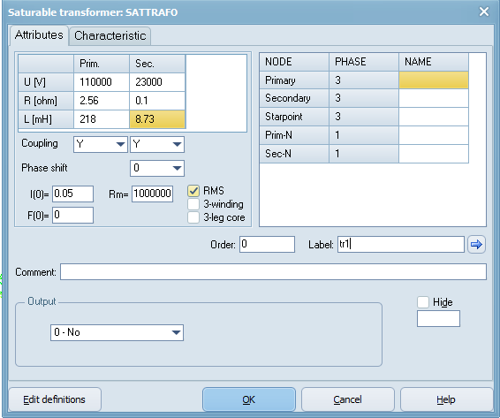

We will not set any saturation:



Finally, both neutral at each side of the transformer has to be grounded.

1. Lines



Line: LCC Template

Settings:

Set #Ph to 4 (4 wires)

Set a name: line1 (line2, line2 .. line6 for the other lines)

Check Skin effect

Check Real transf. matrix.

Set length to 20 km (10 km, 3 km and 1 km for the other lines)

Set line type: PI

check w(C) print out

Standard data as is shown bellow

Check



In Data, first you have to add **a row**

Set the geometry of the line as follow:

* Conductor radius (Rout): 0.95 cm
* Conductor DC resistance: 0.177 Ohm/km
* Three phases conductors 1(A), 2(B), 3(C) are located at the same height of 10 m. The horizontal distribution distances of the conductors are 1.75 m, 0.4m and -1.75 m.
* Regarding the shielding wire or ground wire is located at 11.65 m and centered at the tower (Horizontal =0m).
* In the case of the mid-span for the three phase conductors are assumed to be 9.5 m heights and for the shielding conductor at 11 meters.

|  |  |  |  |
| --- | --- | --- | --- |
| Phase Number | Horizontal | Vtower | Vmid |
| 1 | 1.75 | 10 | 9.5 |
| 2 | 0.4 | 10 | 9.5 |
| 3 | -1.75 | 10 | 9.5 |
| 4 | 0 | 11.65 | 11 |



Grounding of the overhead shielding wire:

The simplest model would be just a resistor but here the inductance of the ground resistance is included. The model is composed by a RL in parallel with a R:



RLC (left branch): R=13 Ohm and L=0.005 mH

R(right branch): 40 Ohm

|  |  |
| --- | --- |
|  |  |

Remember that this is single phase.

1. Load 1 (medium voltage load). Use the RLC-Y-3ph module (RLCY3). Remember that the neutral is the

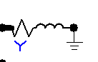

Set for each phase: R to 107.57 Ohm and inductance 616.25 mH

Name Label as: Load 1



1. Medium to low voltage transformer



Saturable three phase transformer (SATTRAFO) settings:

Uncheck 3-winding box.

Coupling: wye-wye

Check RMS box.

Set primary voltage 23000 V

Set secondary voltage 420 V

Set primary impedance 0.168 Ohm and 24 mH

Set secondary impedance 6e-5 Ohm and 0.008 mH.

Set I(0) to 0.05 A

Set Rm to 1 mega-ohms.

Set Label: TR2



We will not set any saturation:



1. Load 2 (low voltage load)



Set for each phase: R to 0.42 Ohm and inductance 4.24 mH

Name Label as: Load 2



1. Surge arrester

Branch --> Non-linear --> MOV

Reference voltage 62000 V.

Set NumPh to 3, that means that this is a three-phase arrestor.

Enable Current measurement Output.



Introduce the V-I characteristic of the MOV arrestor:



You can display (view) the introduced characteristic:



Important: If the lightning surge current is greater than the current defined in your characteristic ATP will provide an error. If this is realistic that would mean a failure of the arrestor. So, in this case we have defined up to 100 kA.

1. Lightning current source

This simulates a lightning return stroke. The current is generated by a Heidler current source and the series resistance represents the lightning channel impedance.

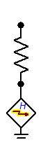

Heidler impulse current source:

Peak current 27000 A. This is the median peak current typically adopted for lightning negative return strokes.

Rise time: T_f=8e-6

tau: 20e-5

n=1

Type: current



Use a 400 Ohm serial resistance to simulate the lightning channel impedance. Enable the Current measurement as Output. A lightning channel during return stroke should have lengths of a couple of km.



**3.3 Investigation of the overvoltage performance of the network**

**3.3.1 Verify the voltages for normal operation**

As an initial point, implement a reduced model of the entire power network. After this, verify that all components are properly configured and working at steady-state and during a transient surge. You can also add the SPD to verify the correct I-V curve.

|  |  |
| --- | --- |
| Steady-state.      Voltages (phase-to-ground) in the phase A at the secondary of the transformer and load. (Here you can see the voltage drop after 20 km of line length). | Lightning strike at the end of the line (close to the load) and on the ground wire.      Overvoltages at the secondary of the transformer and load (**phaseA**-to-ground)  **After installing SPD at both line sides.**    Overvoltages goes down, around 71 kV vs 8 MV without SPD. |

Note: After verifying that the model is working, just gradually add more components and simulate them as the example above.

Place the indicated eight Voltage probes (phase-to-ground voltage probe).



Plot the voltages at:

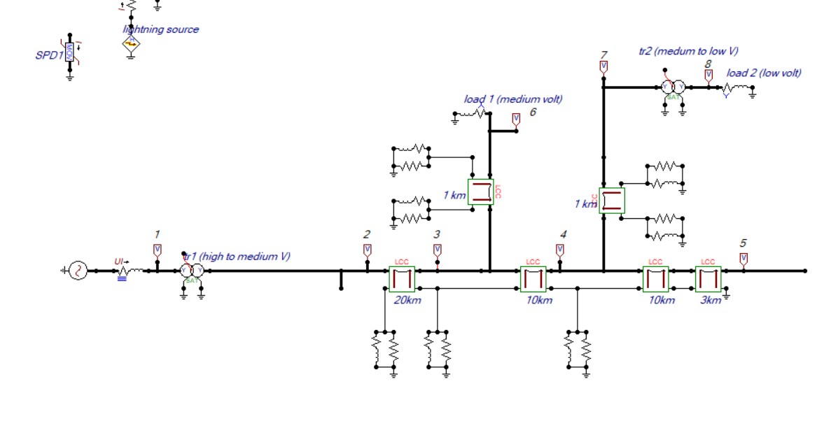

Figure 1, my ATP design

As there are no disturbances and the line loads and transmission lines are perfectly balanced, representing only one phase A makes sense to discuss the whole system.

1 Grid voltage: (only phaseA)

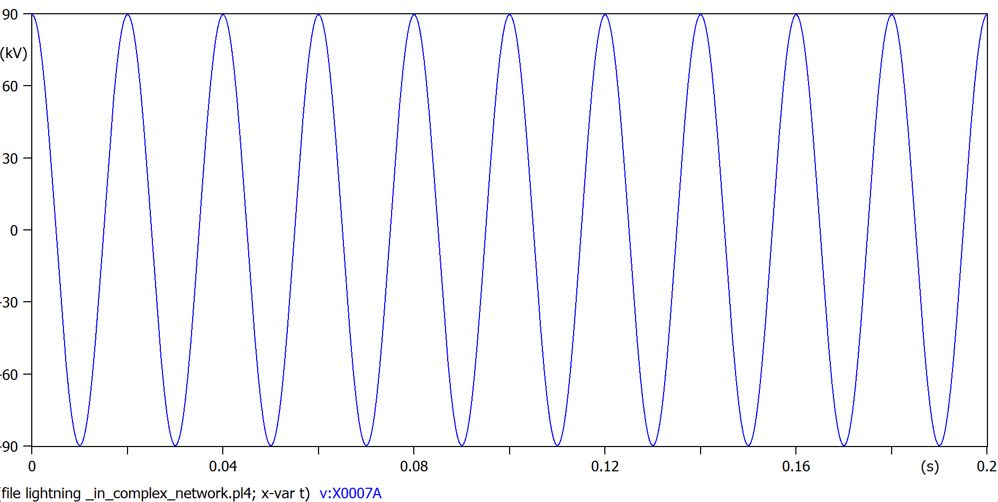

Figure 2, High voltage aprox 90KV

2,3,4,5 after transformer 1: (only phase A)

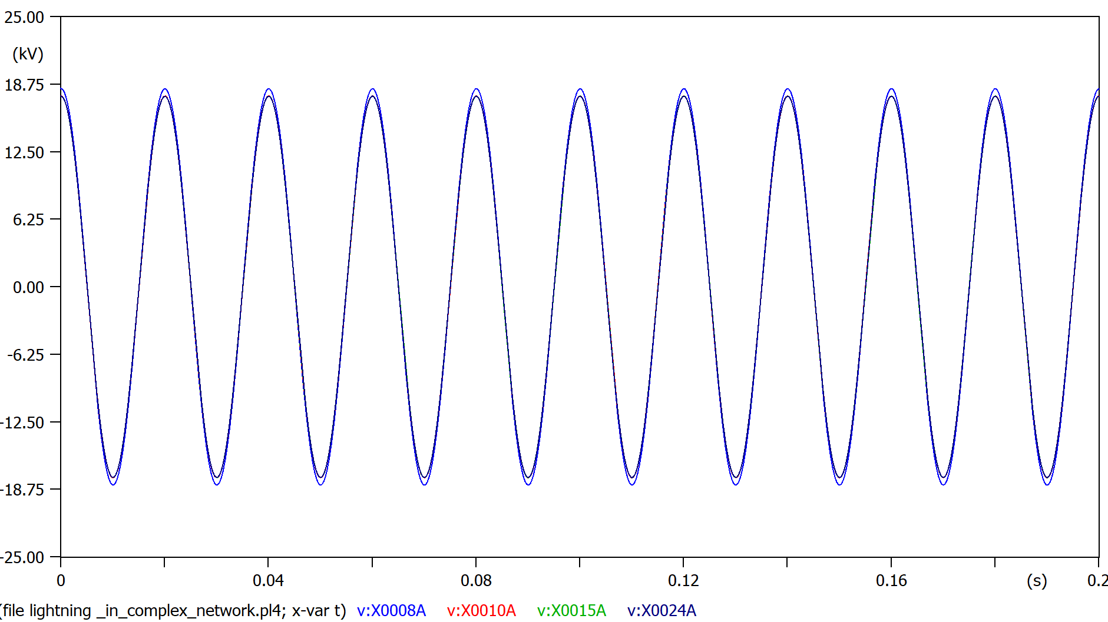

Figure 3, these are all the medium voltage lines (aprox 19KV), the voltage drop due to the transmission lines is noticeable.

6, voltage at load 1: (only phase A)

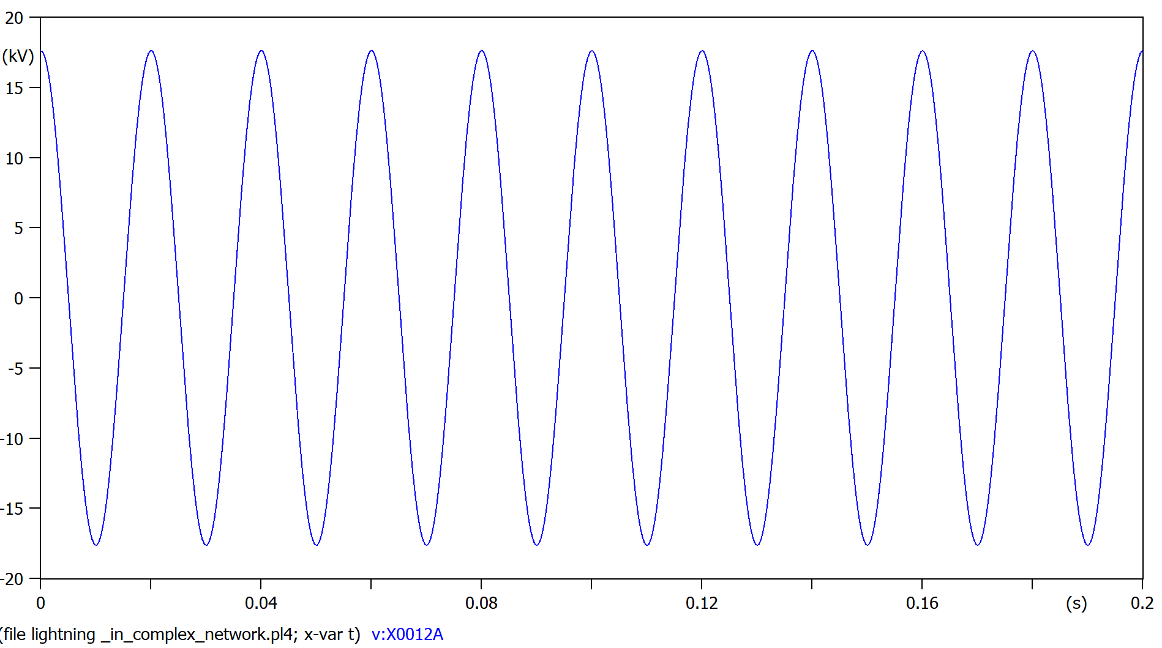

Figure 4, still medium voltage lines but dropped down to 17KV due to the presence of load1 and the 1Km transmission line

7, right before transformer 2 (only phase A)

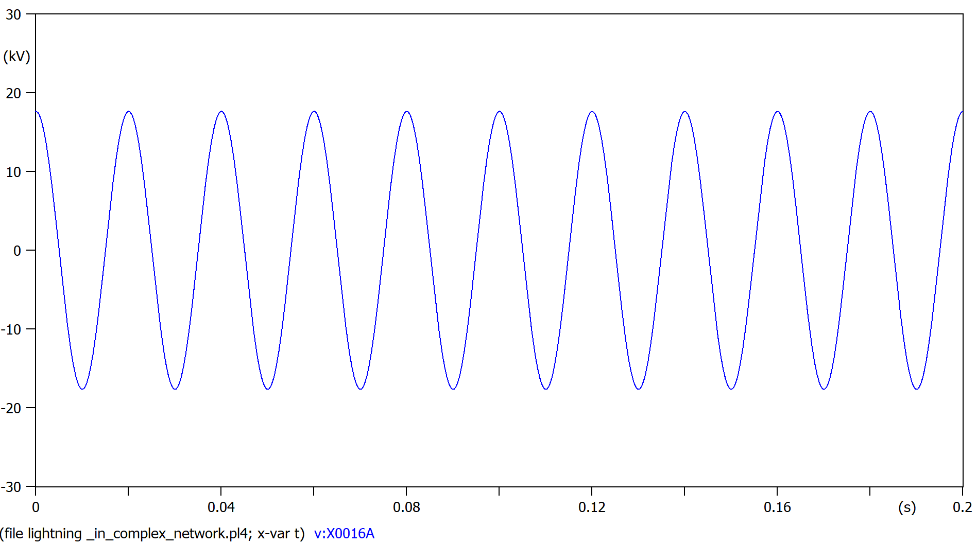

Figure 5, still medium voltage lines, about 17KV, similar situation to figure 4

8, voltage after transformer 2: (only phase A)

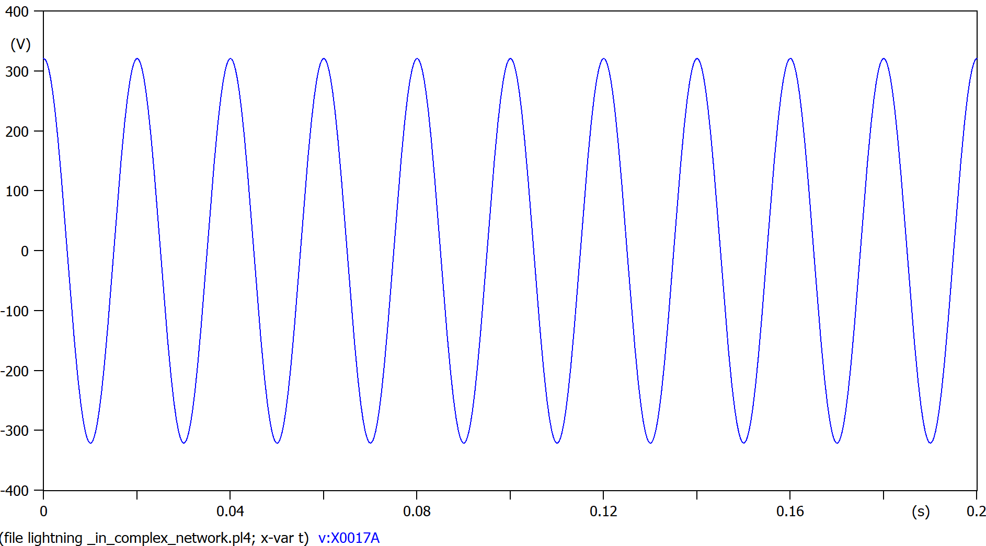

Figure 6, low voltage line, about 320V ready to be distributed to consumers (load2)

**3.3.1 Investigate the voltages when a lightning strike at the end of the line**

Connect the lightning current source to phase A the end of the line.



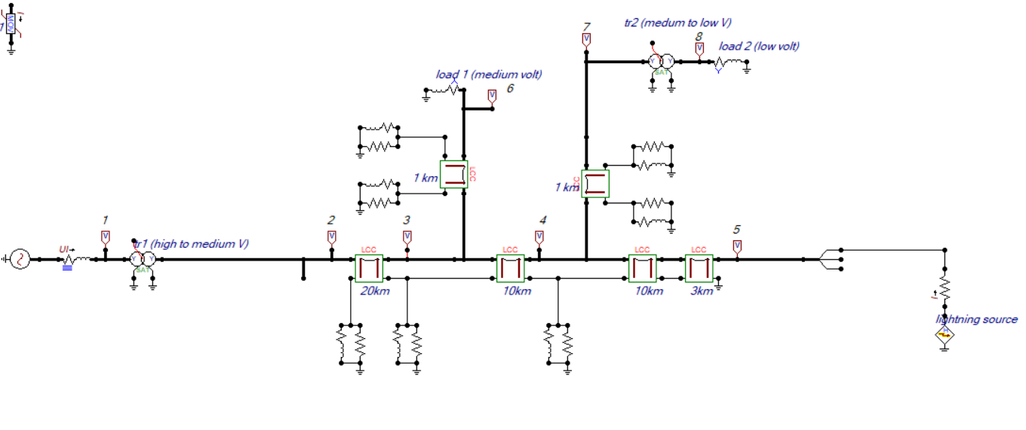

Figure 7, my ATP model with the lightning disturbance

Plot the voltages at:

1 Grid voltage HV with disturbance: (all phases)

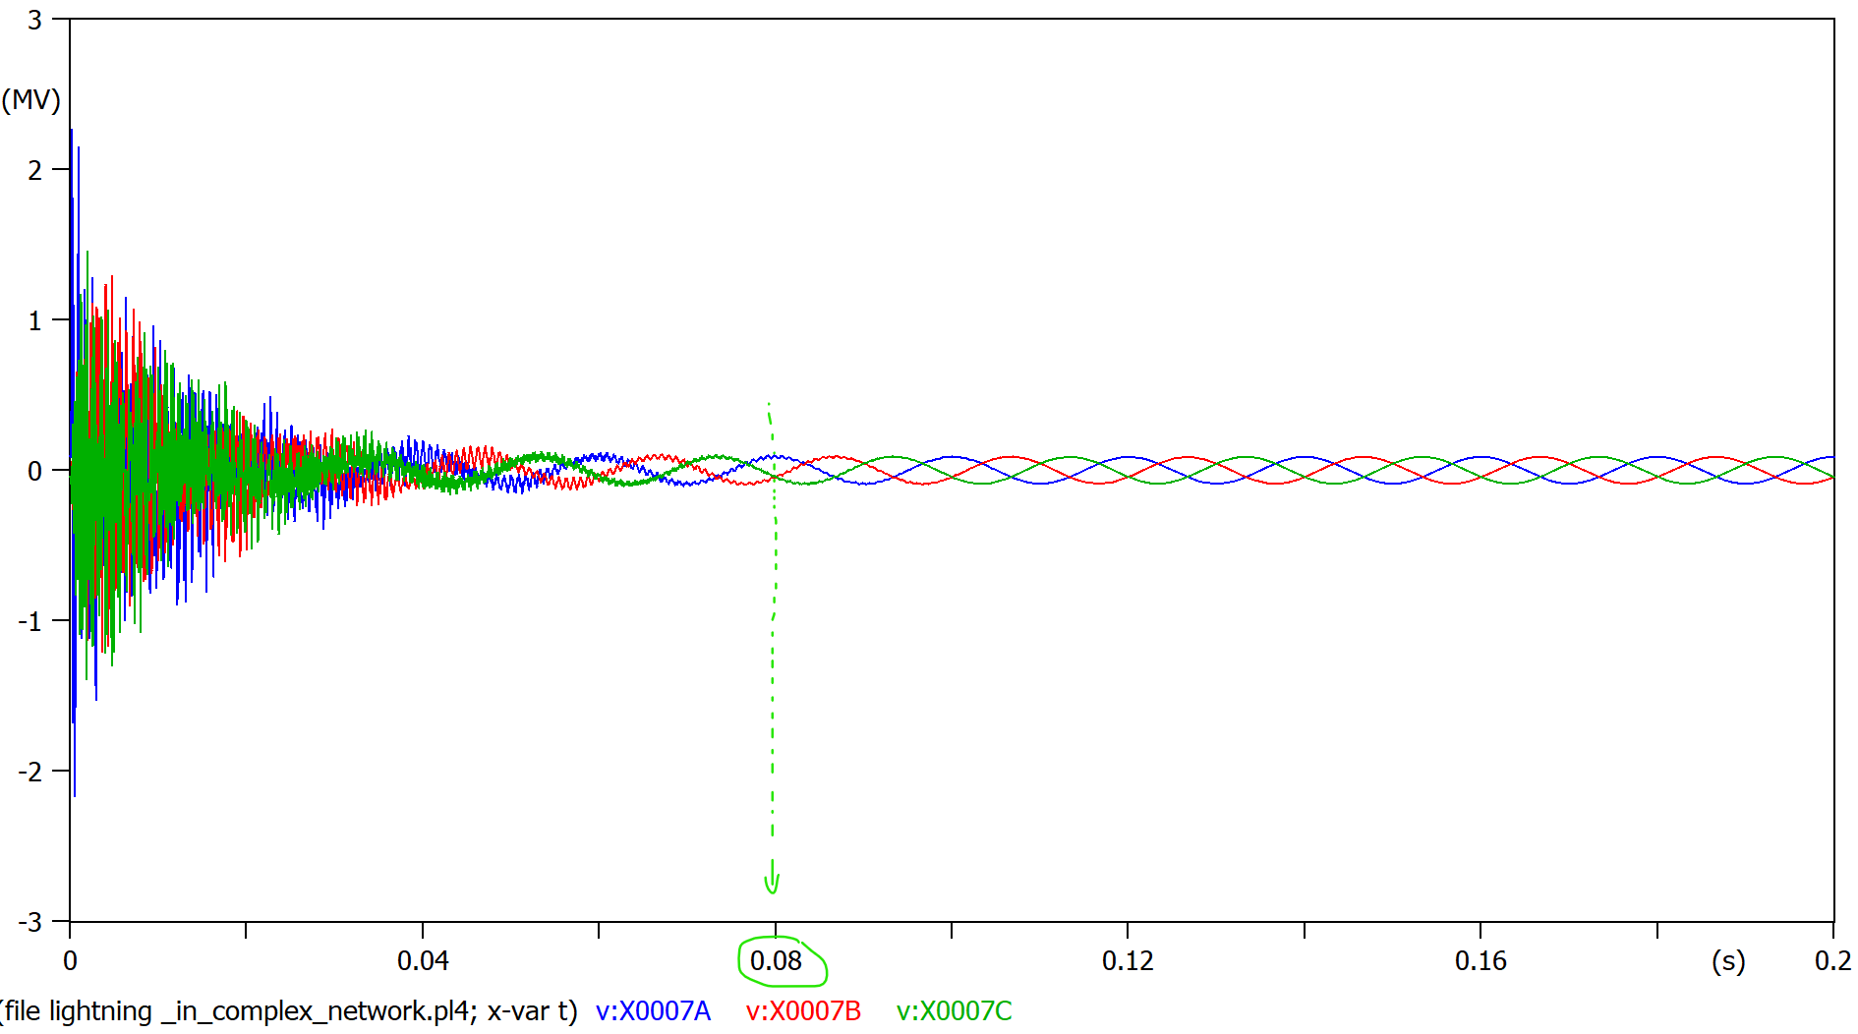

Figure 8, notice the phase A(blue) is the one with the greater voltage overaload, the fault is cleared in about 0.08 s

2, right after transformer 1, medium voltage line with disturbance

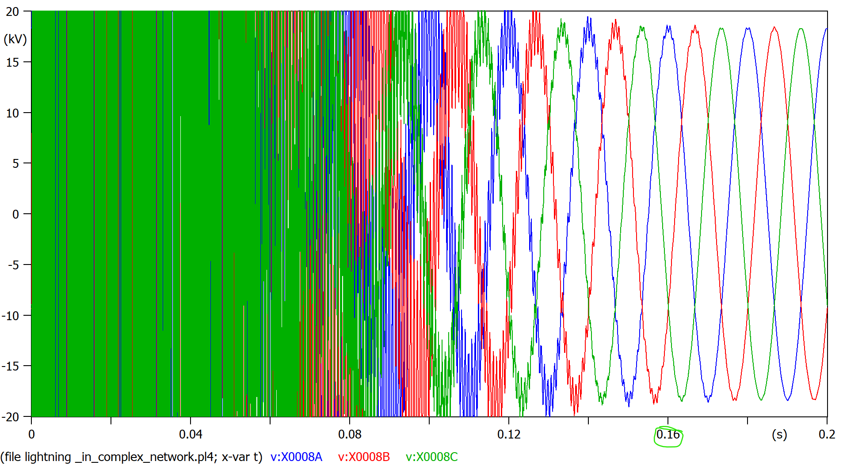

Figure 9, closeup snap (fault voltages reach 5MV), notice the fault is cleared in 0.16s

3 in between transmission lines, medium voltage with disturbance

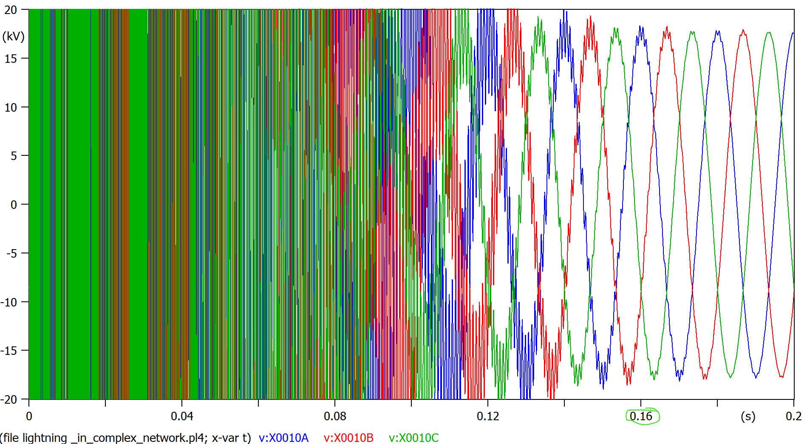

Figure 10, closeup snap (fault voltages reach 15MV), similar to figure 9, fault clears in 0.16s aswell

4, similar to 3 but closer to the disturbance

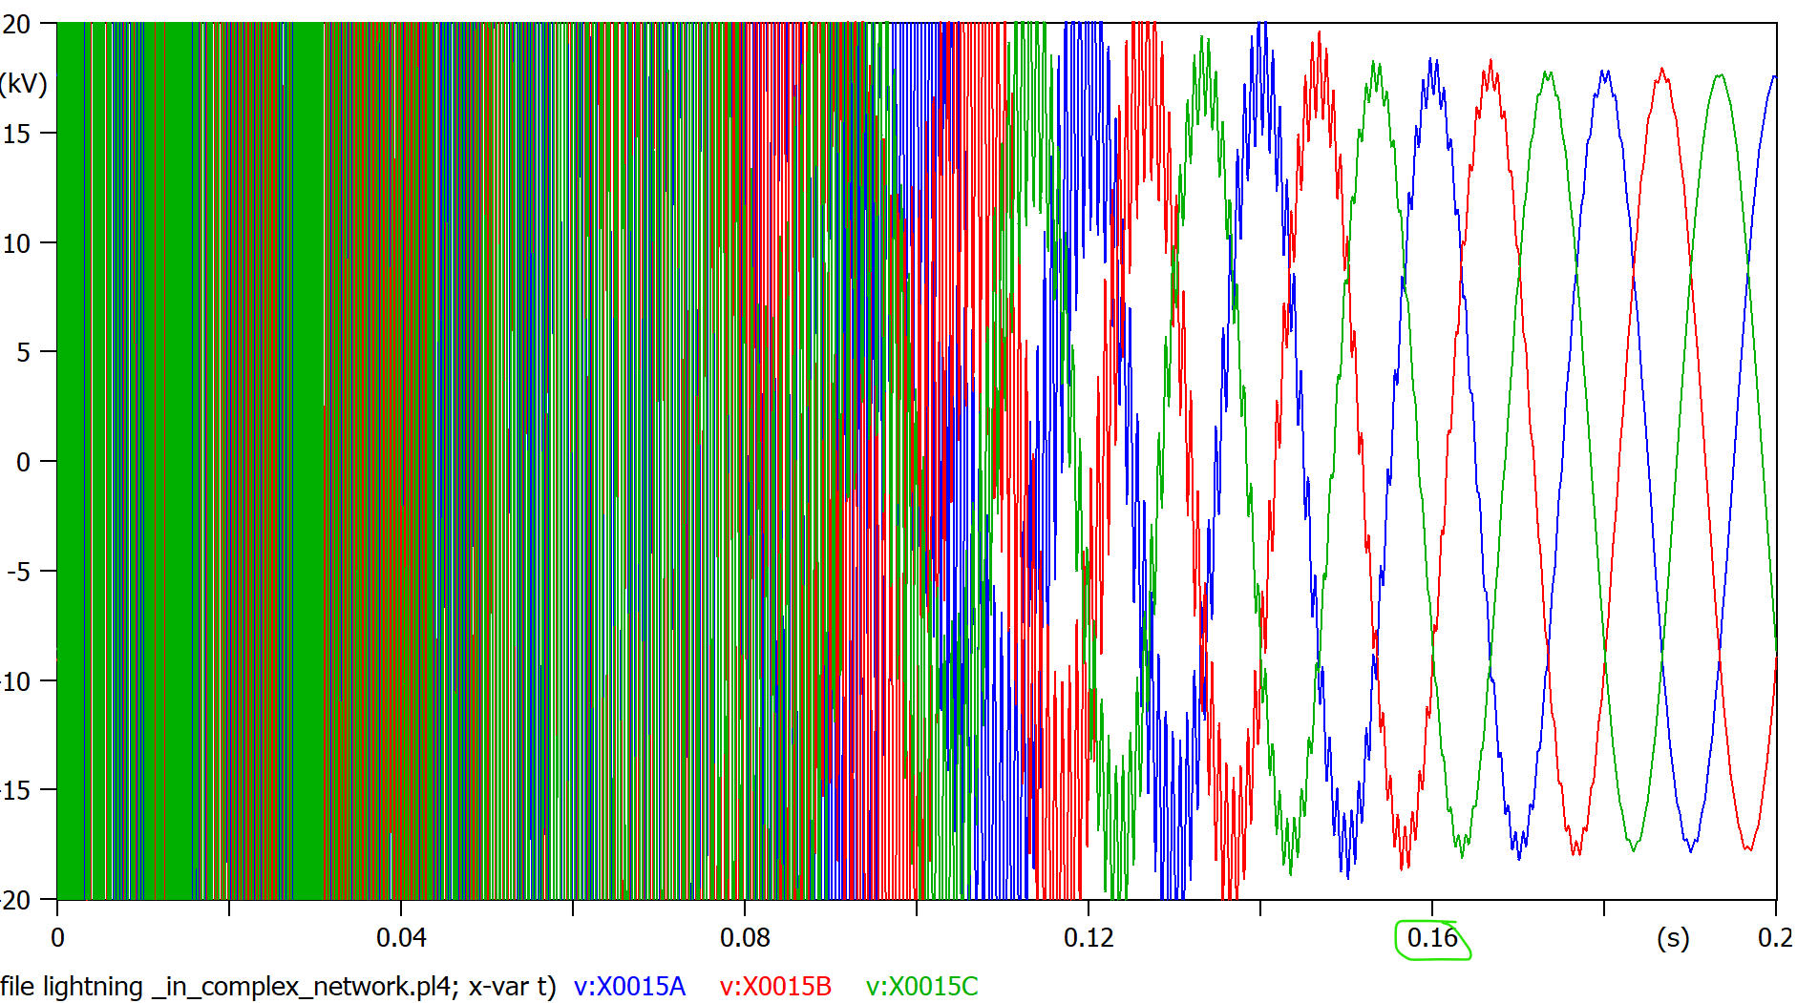

Figure 11, the same as figs 9 and 10, notice how we are moving closer to the disturbance , the overvoltage increases and the clearing time lightly increases as well

5, measuring the medium voltage line right at the disturbance

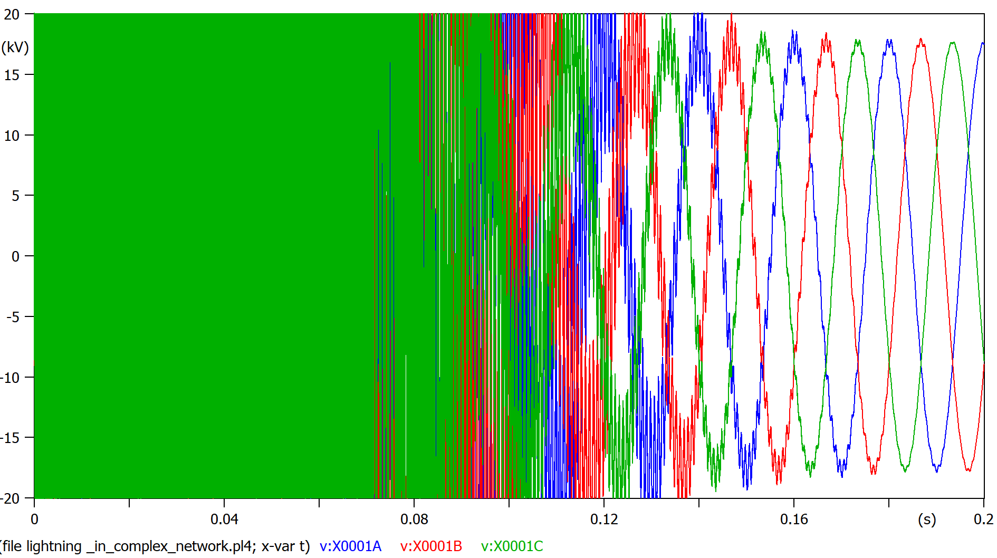

Figure 12, worse case of disturbance, 25MV overvoltages, and clearing time closer to 0.2s

6, voltage right at load1

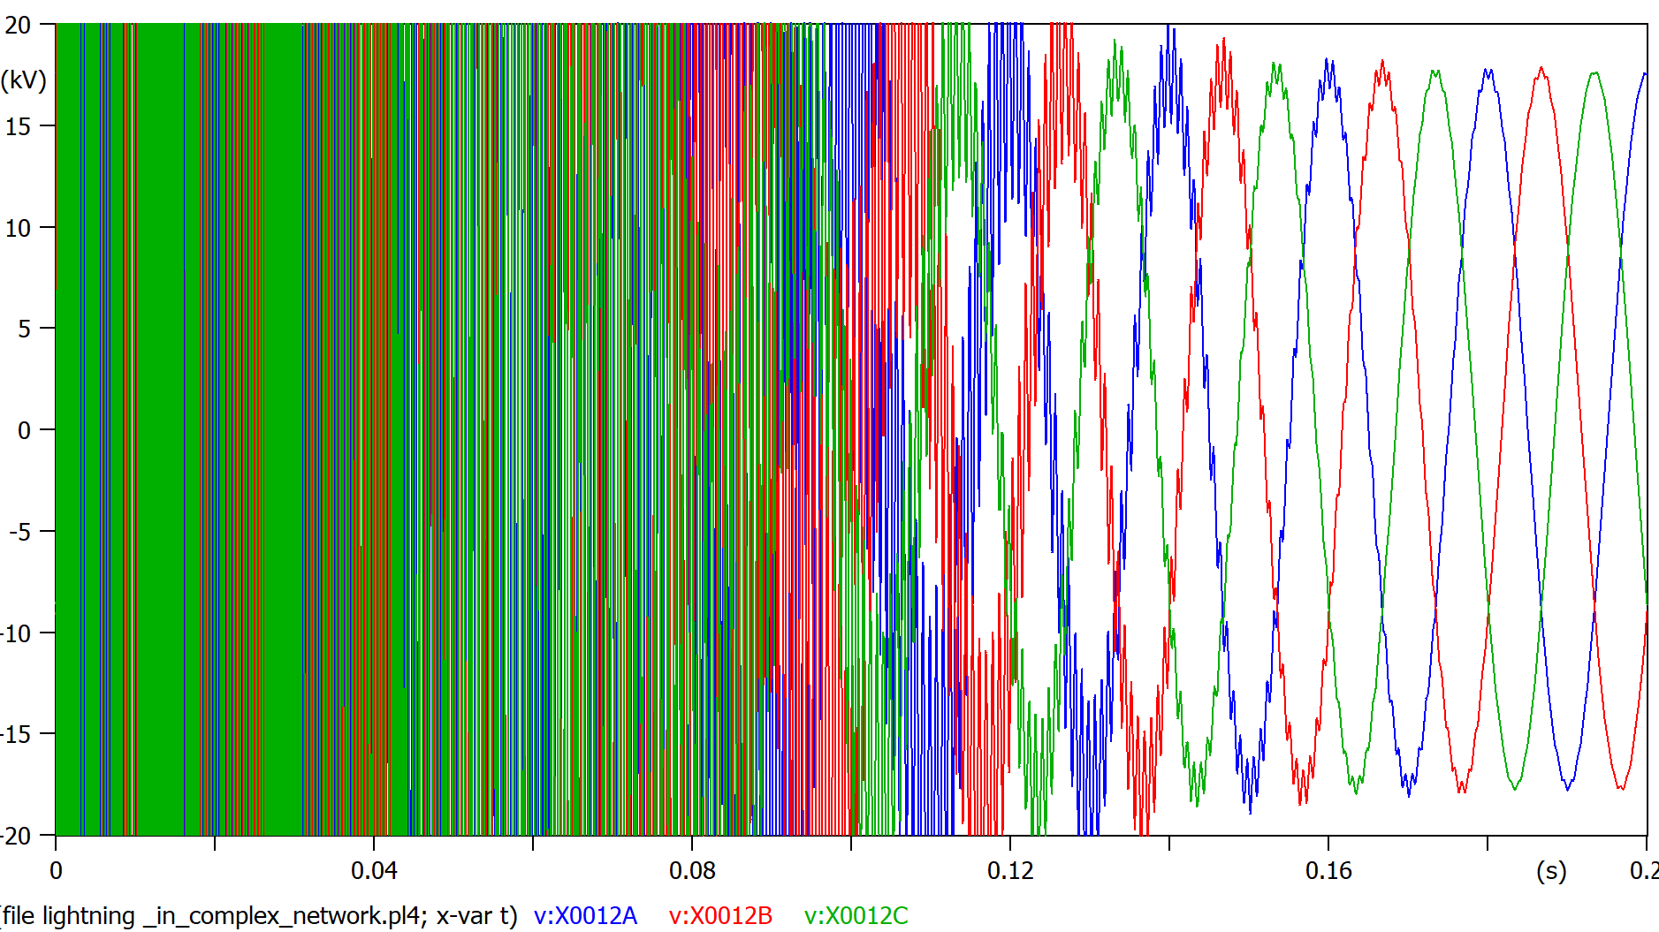

Figure 13, similar to figure 9, 15MV overvoltage and about 0.18s clearing time

7, right after transformer 2

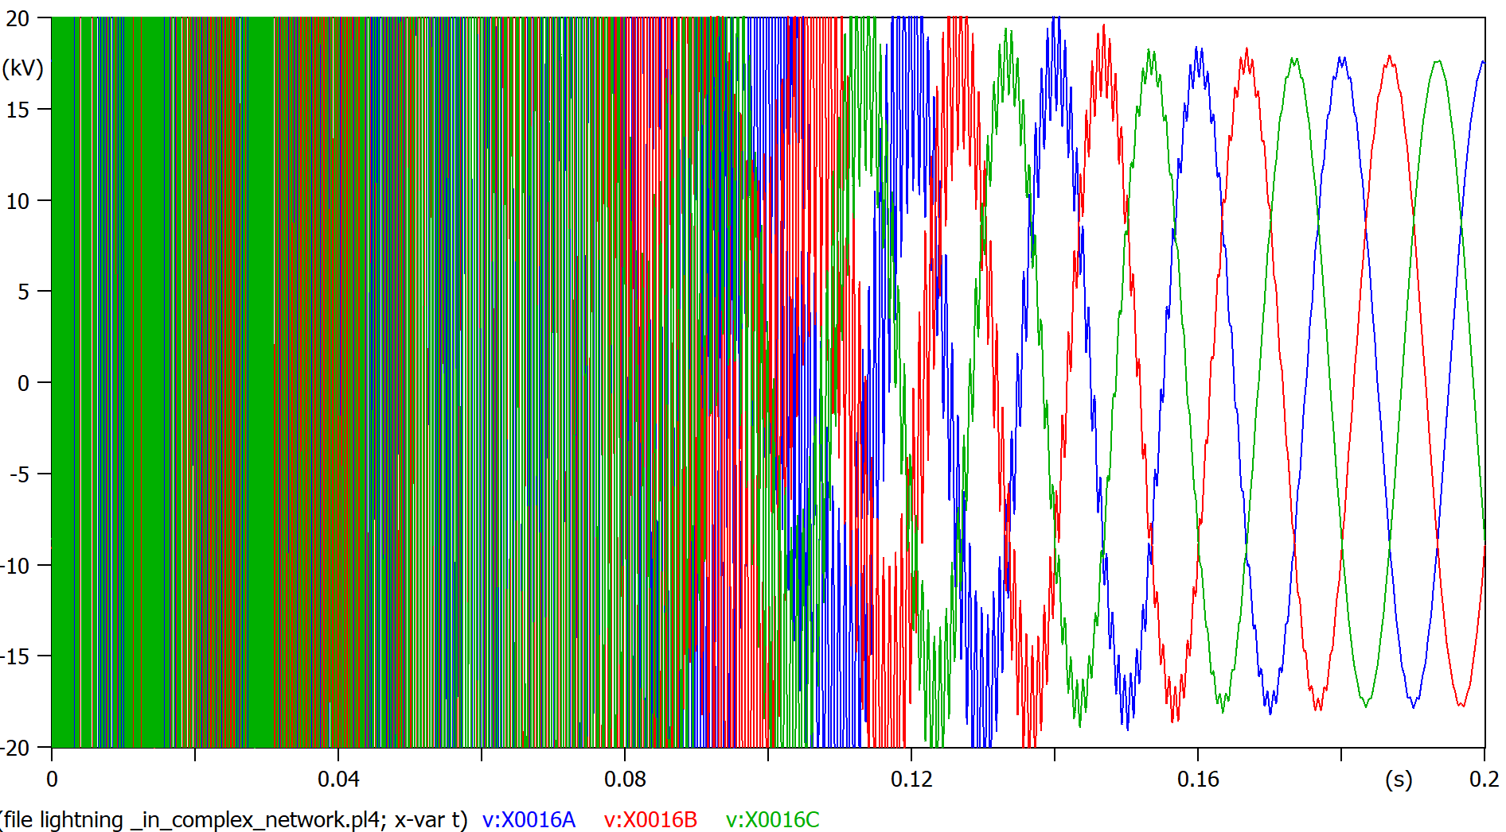

Figure 14, almost identical situation than figure 13

8, after transformer 2, low voltage

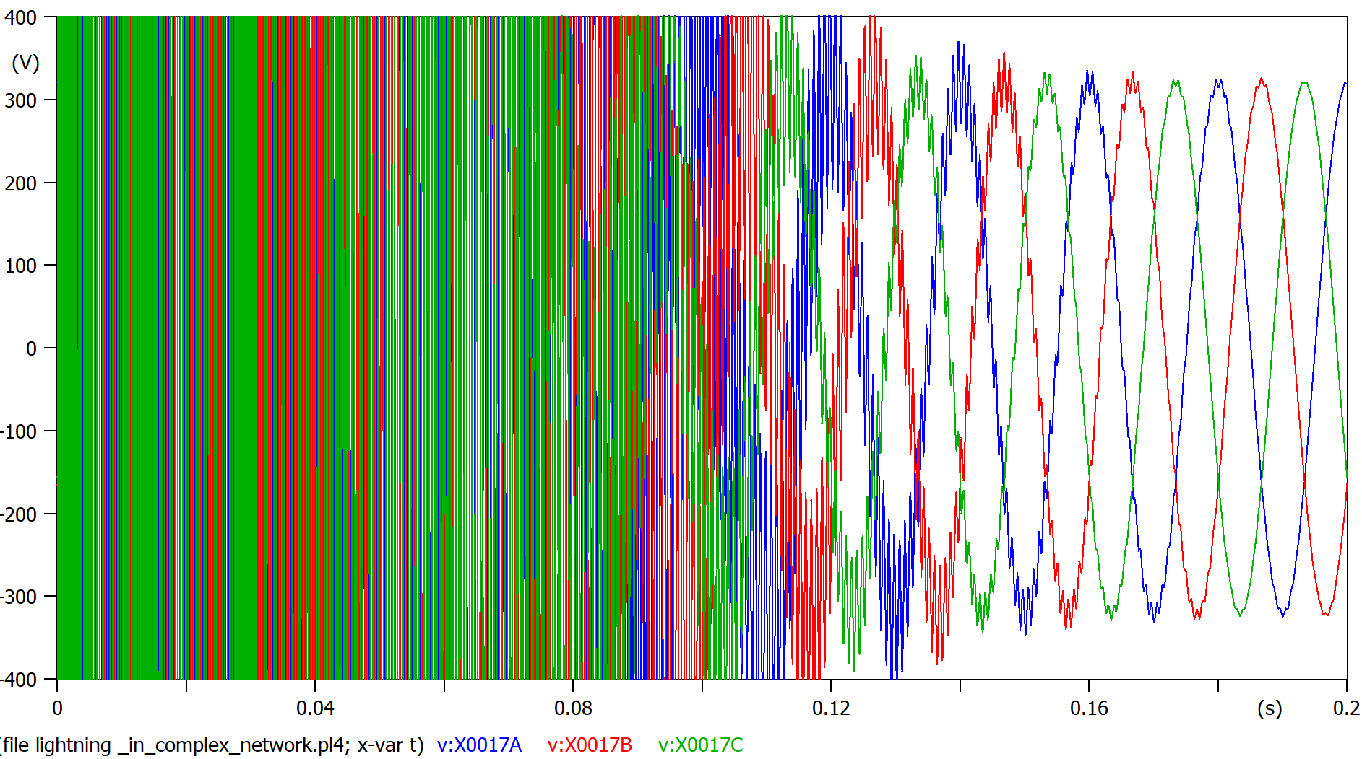

Figure 15, 250KV volts of vershoot and similar 0.17s clearing time than other measurements

Plot the lightning current (zoom enough to see details).

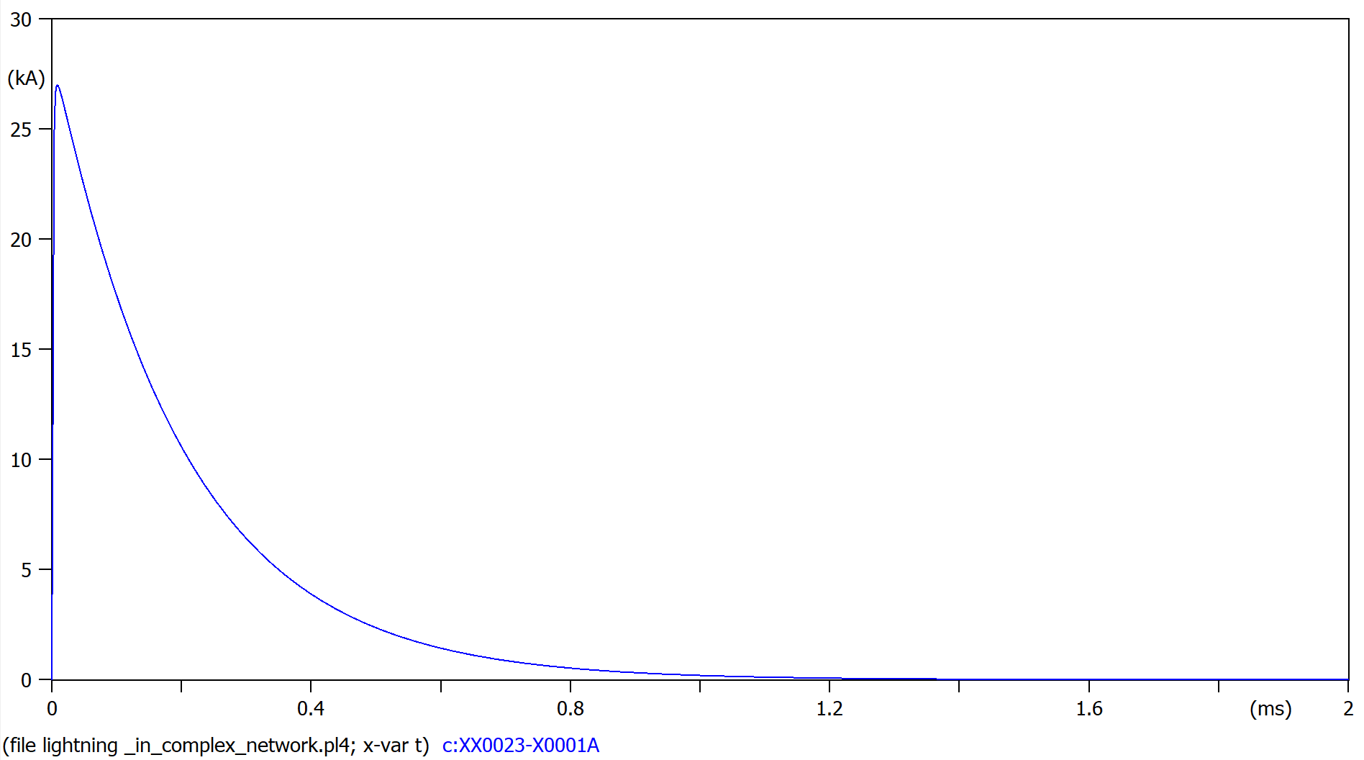

Figure 16, the current shape follows our parameters, 0,8us settling time and 27KA peak

Indicate if the electrical insulation will fail among the eight measured locations.

As the BIL of the lines is 150KV, all lines will fail.

**3.3.3 Add a surge arrester in parallel with Load 1 and investigate the voltages**

Connect the surge arrester (MOV) in parallel with load 1.



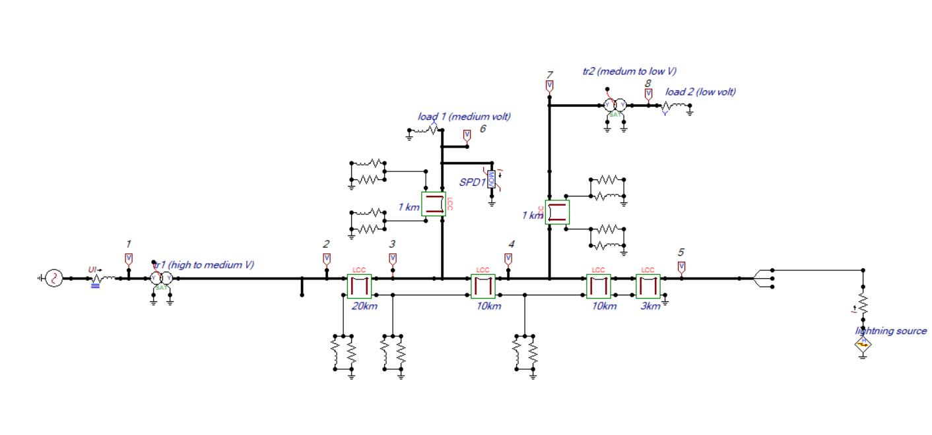

Figure 17, my ATP with surge arrester at load 1

Plot the voltages at:

1, at the grid (HV side)

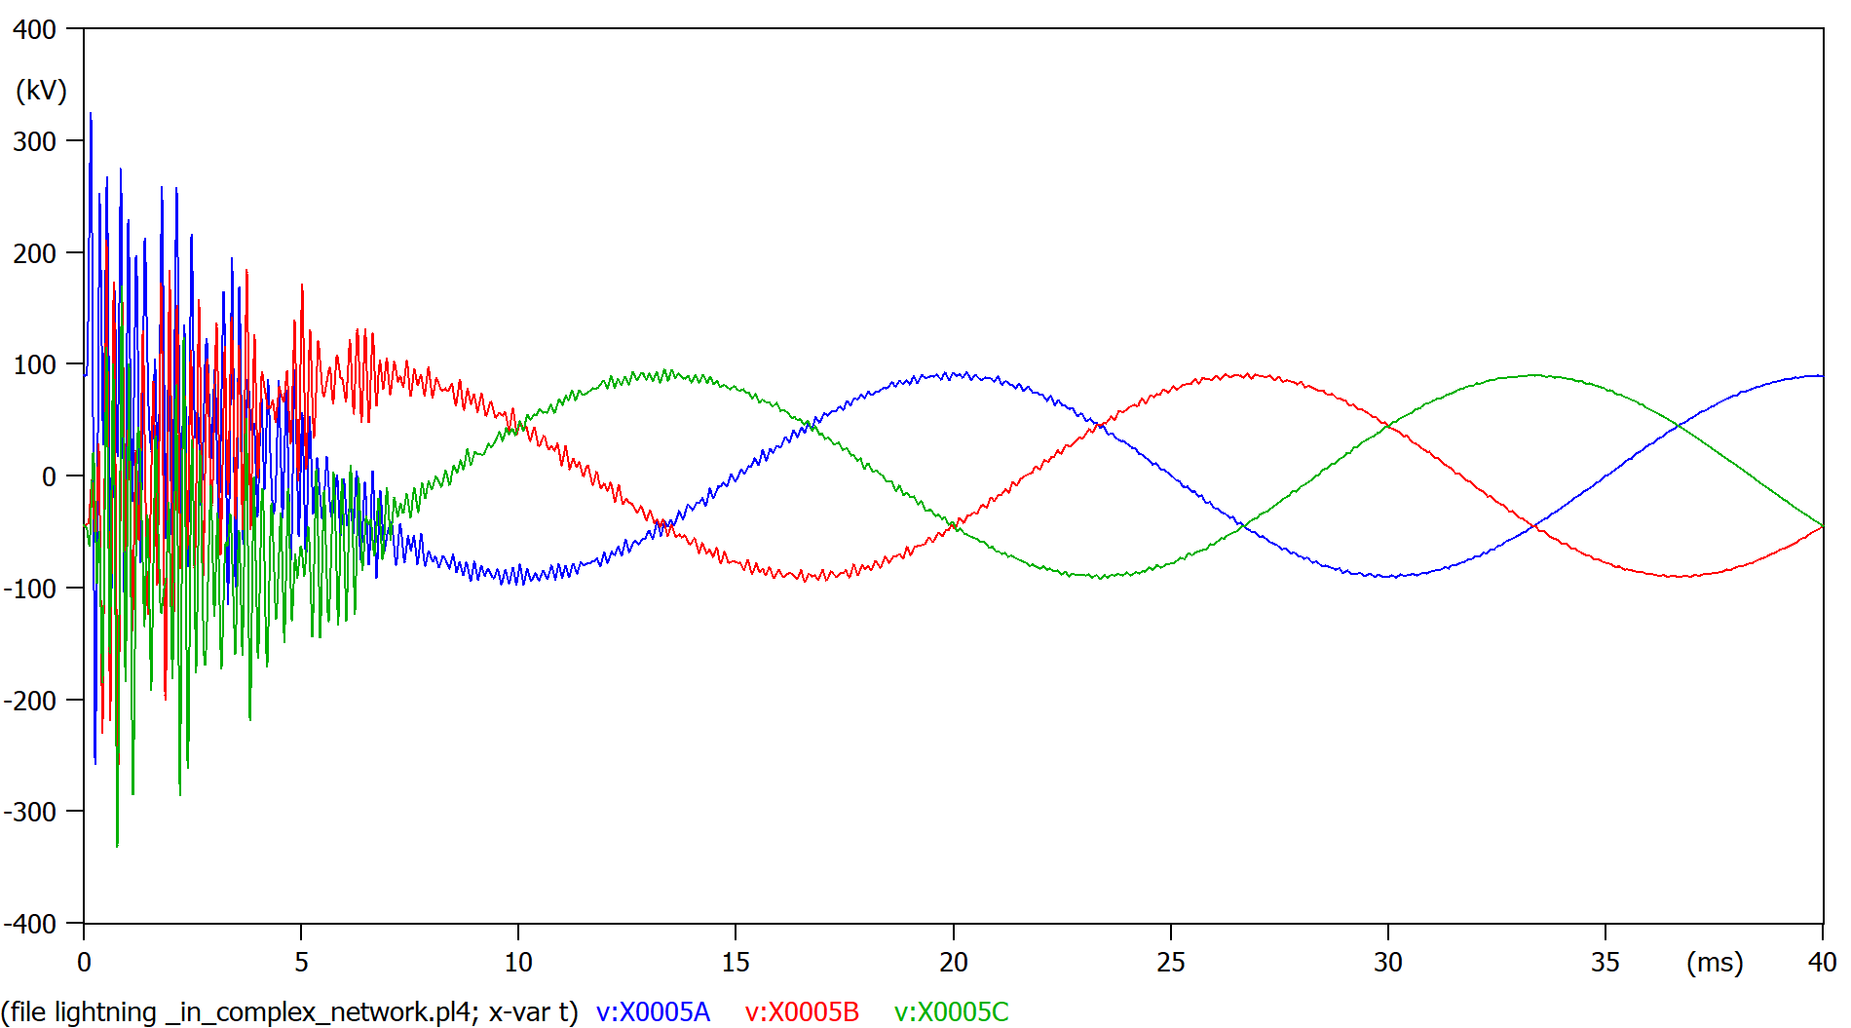

Figure 18, dramatic drop in overvoltage down to 350KV, clearing time drops to 15ms aprox.

The closer you move to the disturbance and further from the surge arrester the worse overvoltages we see:

2, grid (MV side)

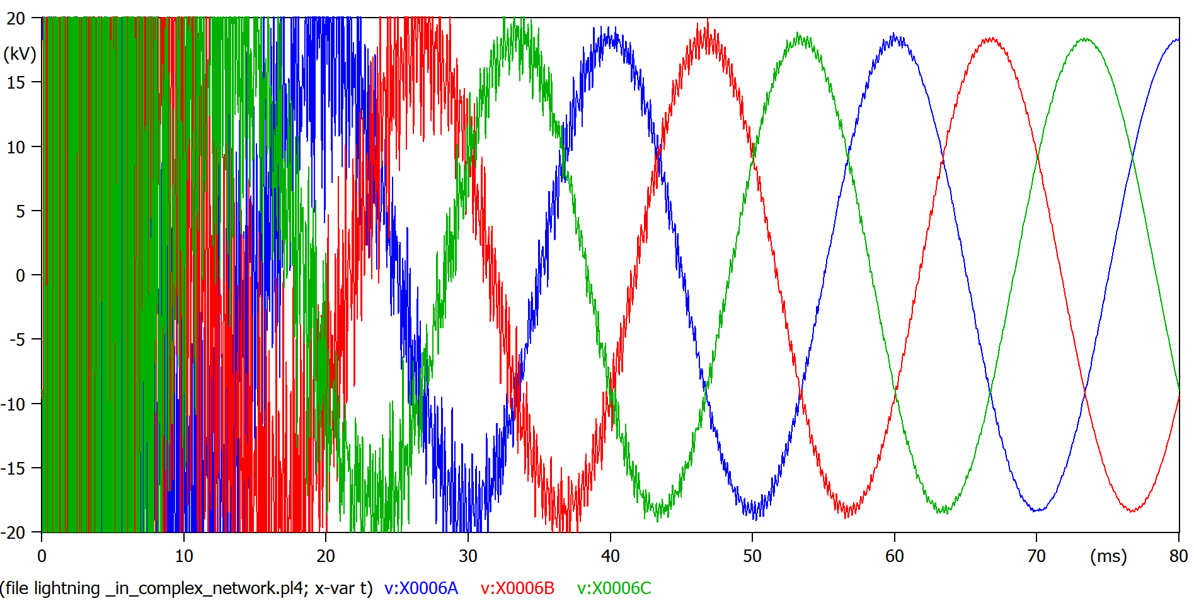

Figure 19, 900KV of overvoltage

3, between lines, closer to disturbance and surge arrester

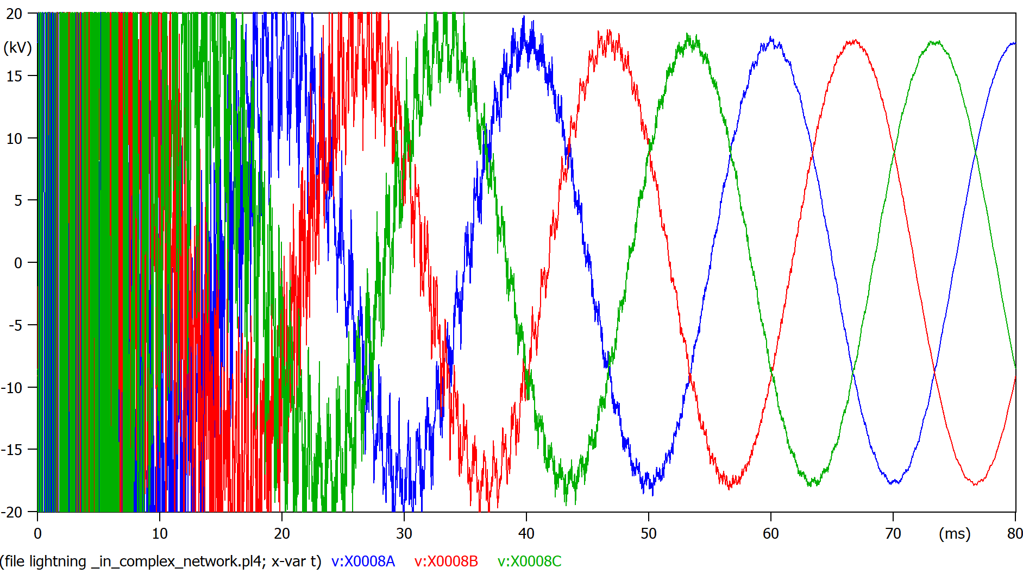

Figure 20, worse overshoot (1,5MV), the influcene of the disrturbance is bigger than figure 19, still improvemet of 10x less overvoltage than the same situation with no surge arrester.  
Clearing time is much shorter.

4, similar to 3 but closer to the disturbance

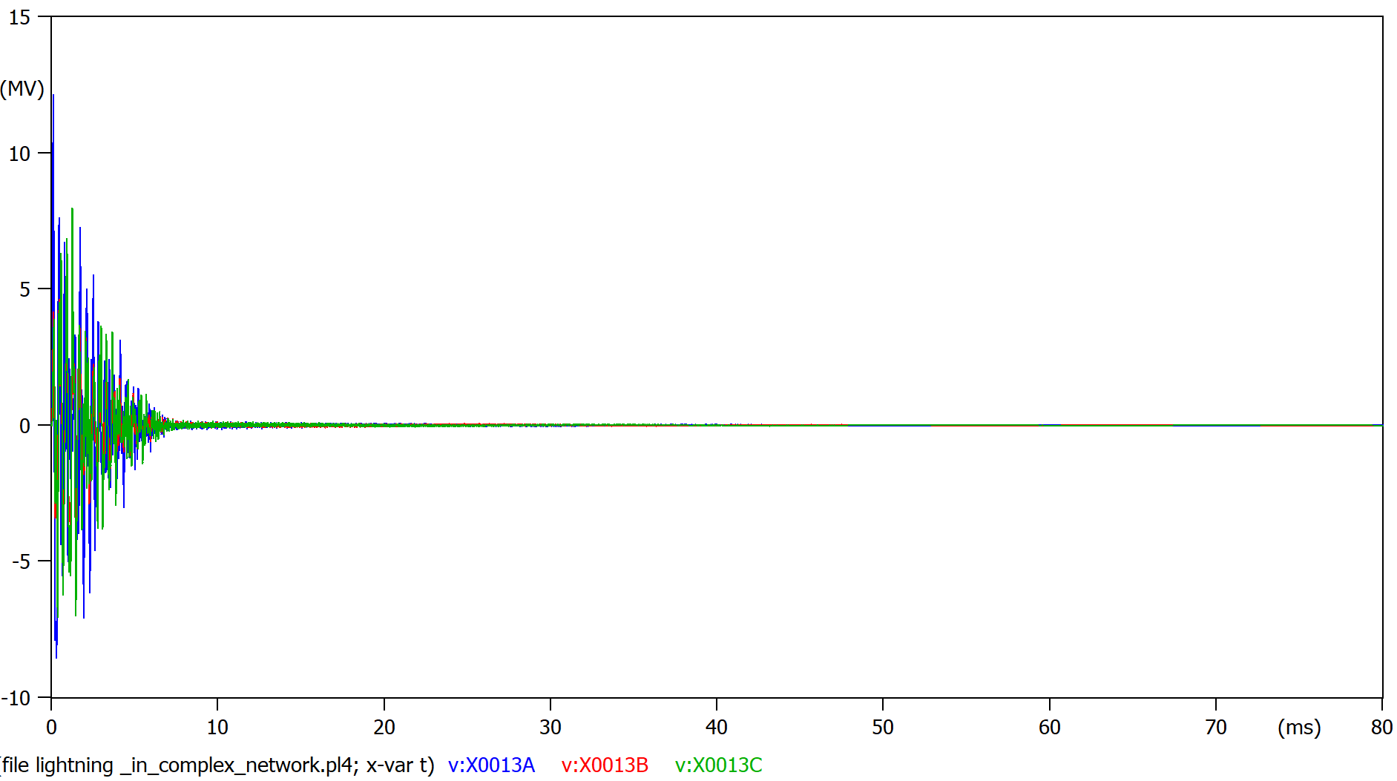

Figure 21, zoom out for the overvoltage (arounf 13MV) , still small improvement from the figure11, SPD has almost no effect here.   
Clearing time is much shorter.

5, measuring the medium voltage line right at the disturbance

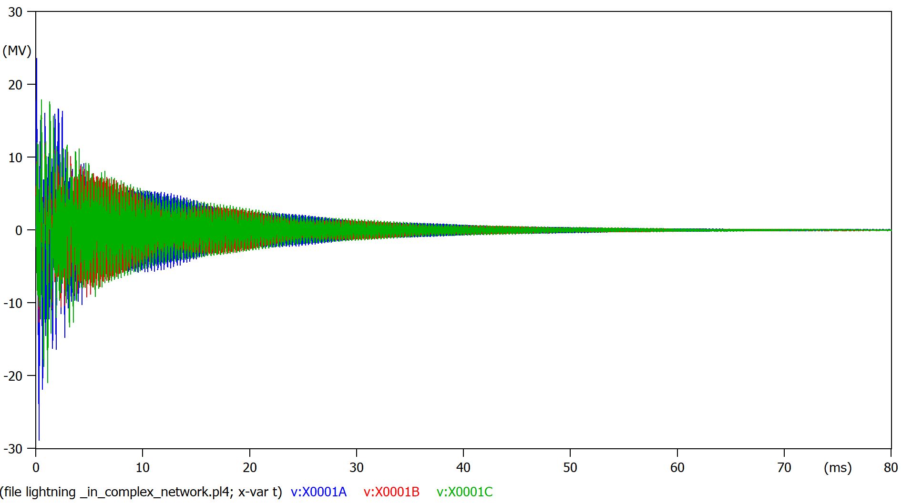

Figure 22,almost no noticeable improvement from figure 15, still 25MV overshoots.  
 Clearing time is much shorter.

6, voltage right at load1 (the one closer to the surge arrester)  
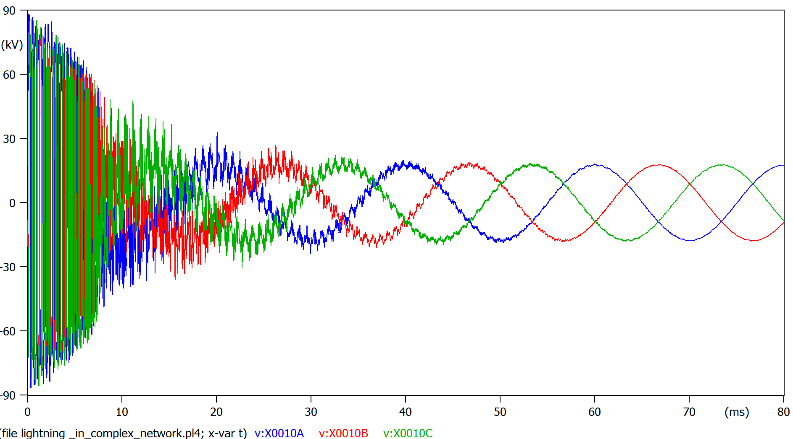

Figure 23, overvoltages drop to 90KV and the fault clears super-fast in 50ms

7, right after transformer 2

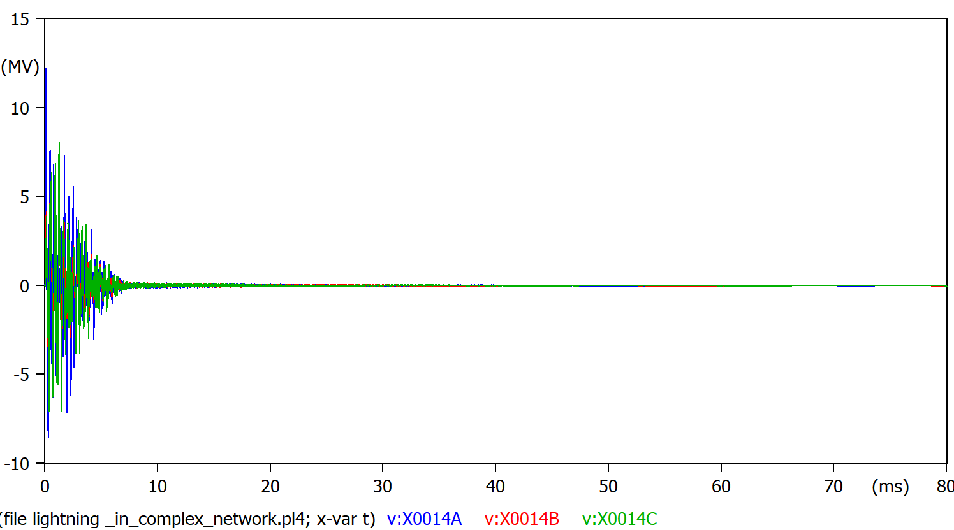

Figure 24, almost no eefect of the SPD regarding to voltage overshoot, but the clearing time dramatically improves.

8, after transformer 2, low voltage

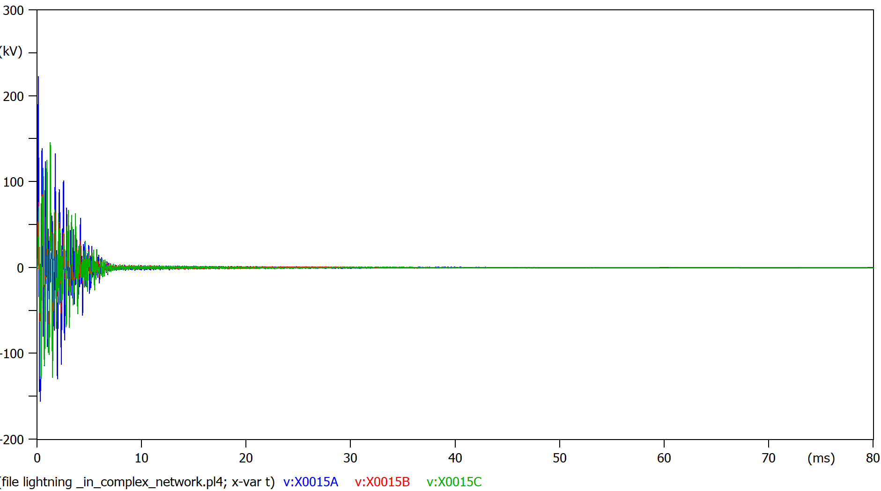

Figure 25,equivalent to figure 24 but in low voltage.

Plot the current at the surge arrestor (remember that current measurement has been enabled in the arrestor properties).

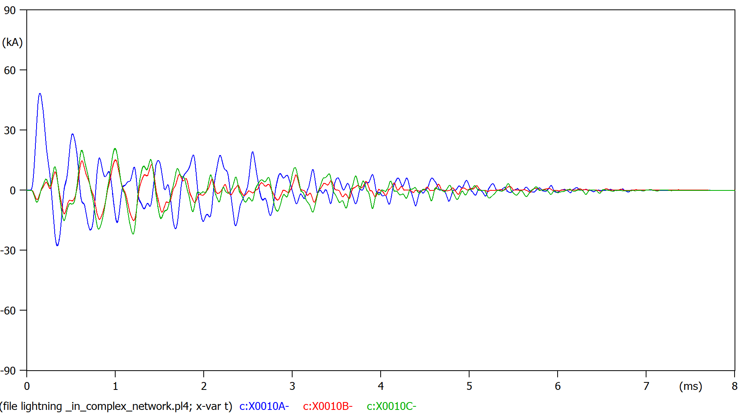

Figure 26, the surge arrestor only derives current to ground when an overvoltage is detected

Indicate if the electrical insulation will fail among the eight measured locations.

As the isolation level is still 150KV ,all lines will still fails except the one we just placed the surge arrester on.

At Figure 23, load1 suffers an overvoltage of only 90Kv, the isolation wont fail.

**3.3.4 Add more surge arresters to avoid the failure of the electrical insulation**

Now distribute the surge arrestors in order to avoid a failure of the electrical insulation in all the network. If you need arrestors for the grid side or at the low voltage side (eg. at probe 8), search on the internet for characteristics of these arrestors.

Plot the voltages at:

1, at the grid (HV side)

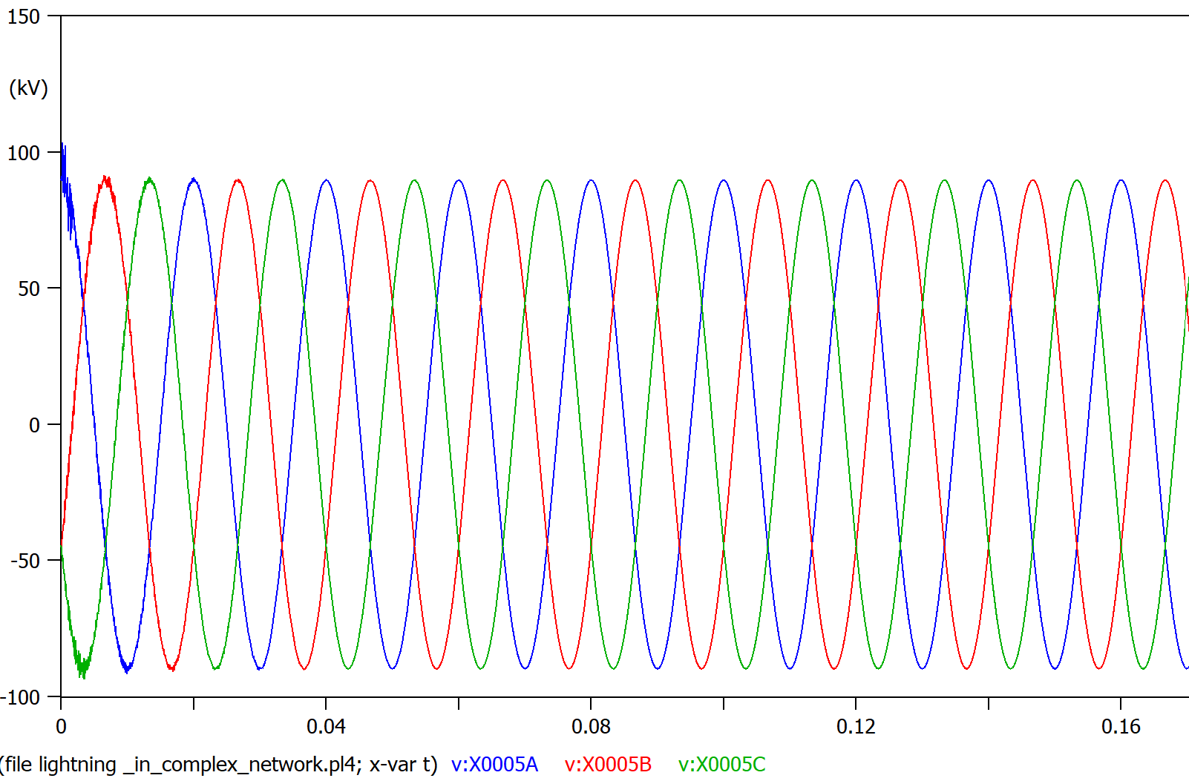

Figure overvoltage 100Kv<150Kv, isolation holds

2, grid (MV side)

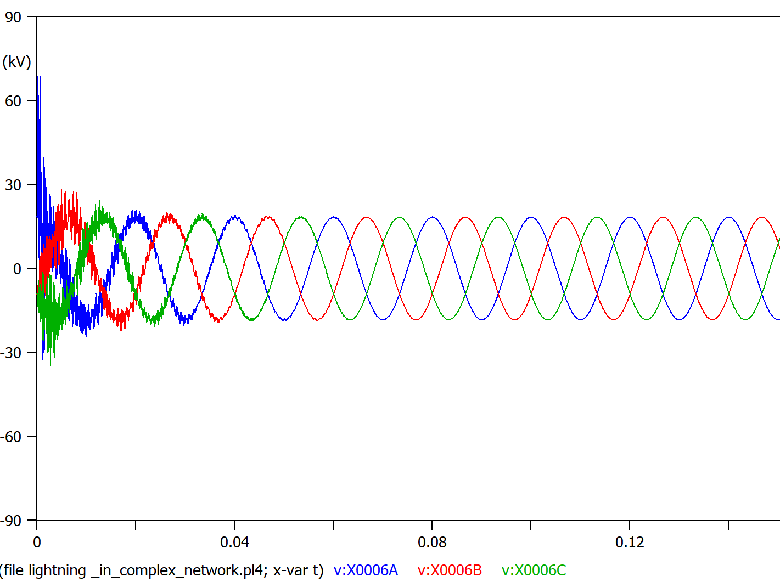

Figure overvoltage 80Kv<150Kv, isolation holds

3, between lines, closer to disturbance and surge arrester

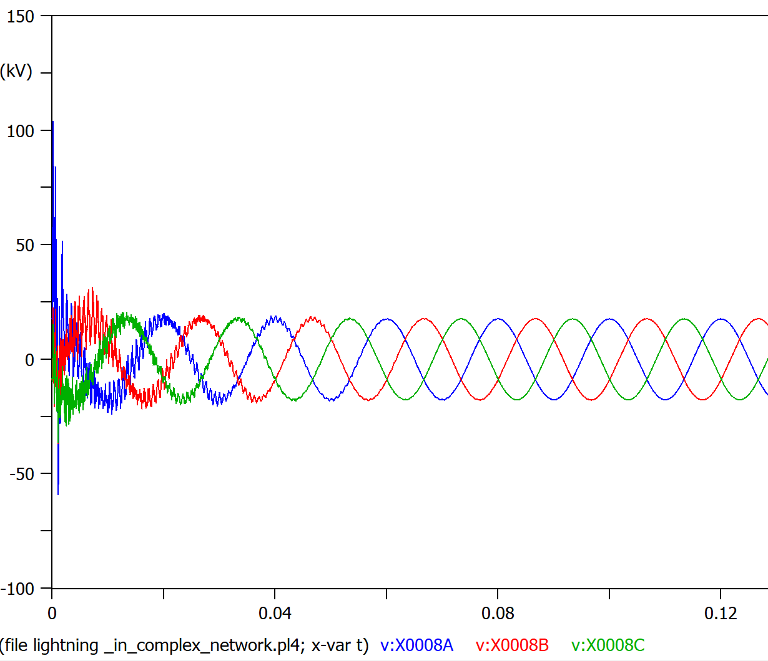

Figure overvoltage 100Kv<150Kv, isolation holds

4, similar to 3 but closer to the disturbance

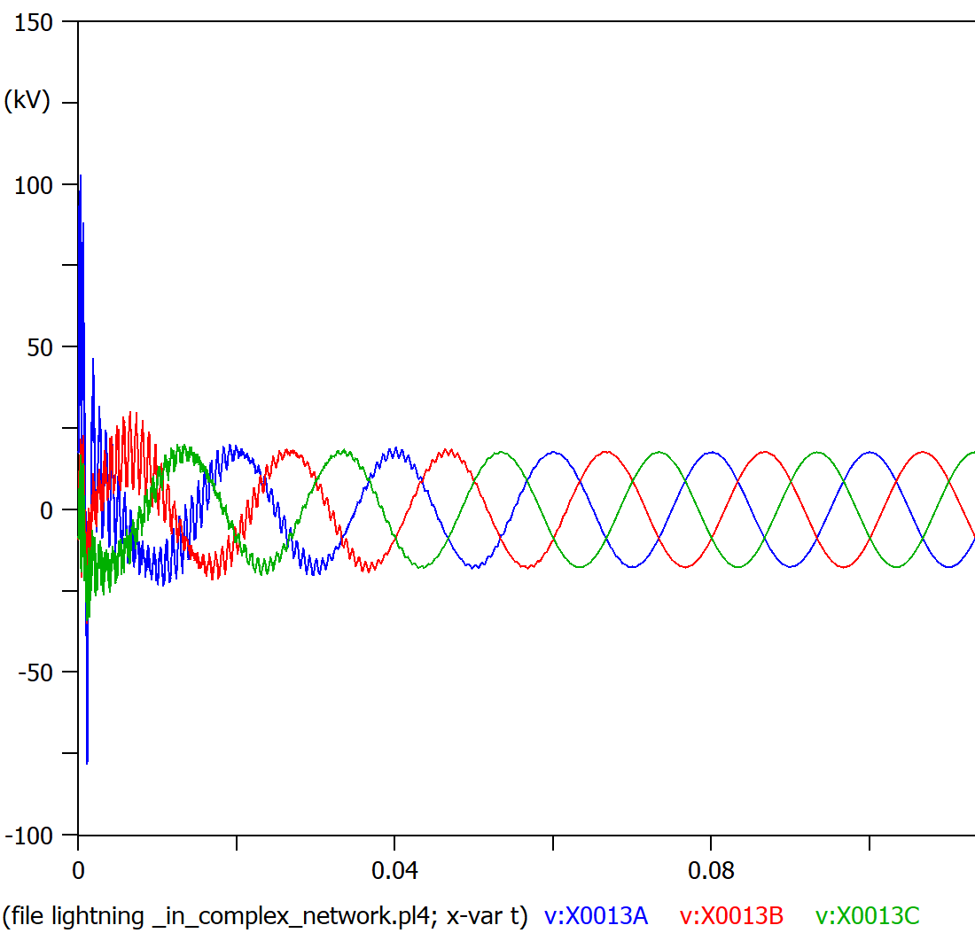

Figure overvoltage 100Kv<150Kv, isolation holds

5, measuring the medium voltage line right at the disturbance

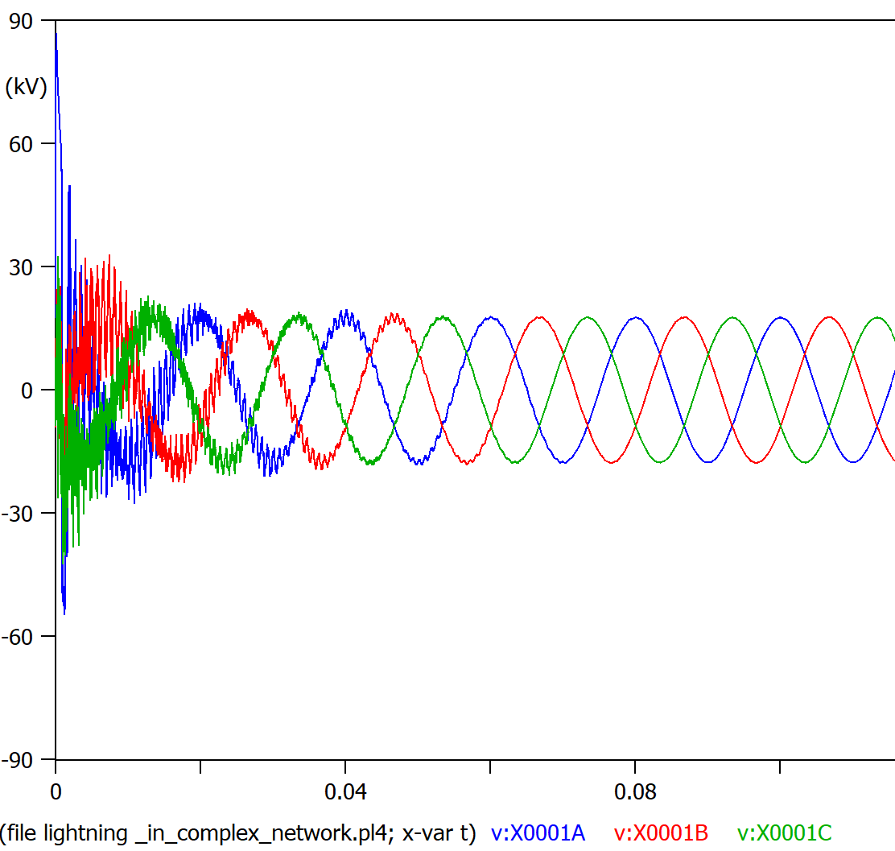

Figure overvoltage 90Kv<150Kv, isolation holds

6, voltage right at load1

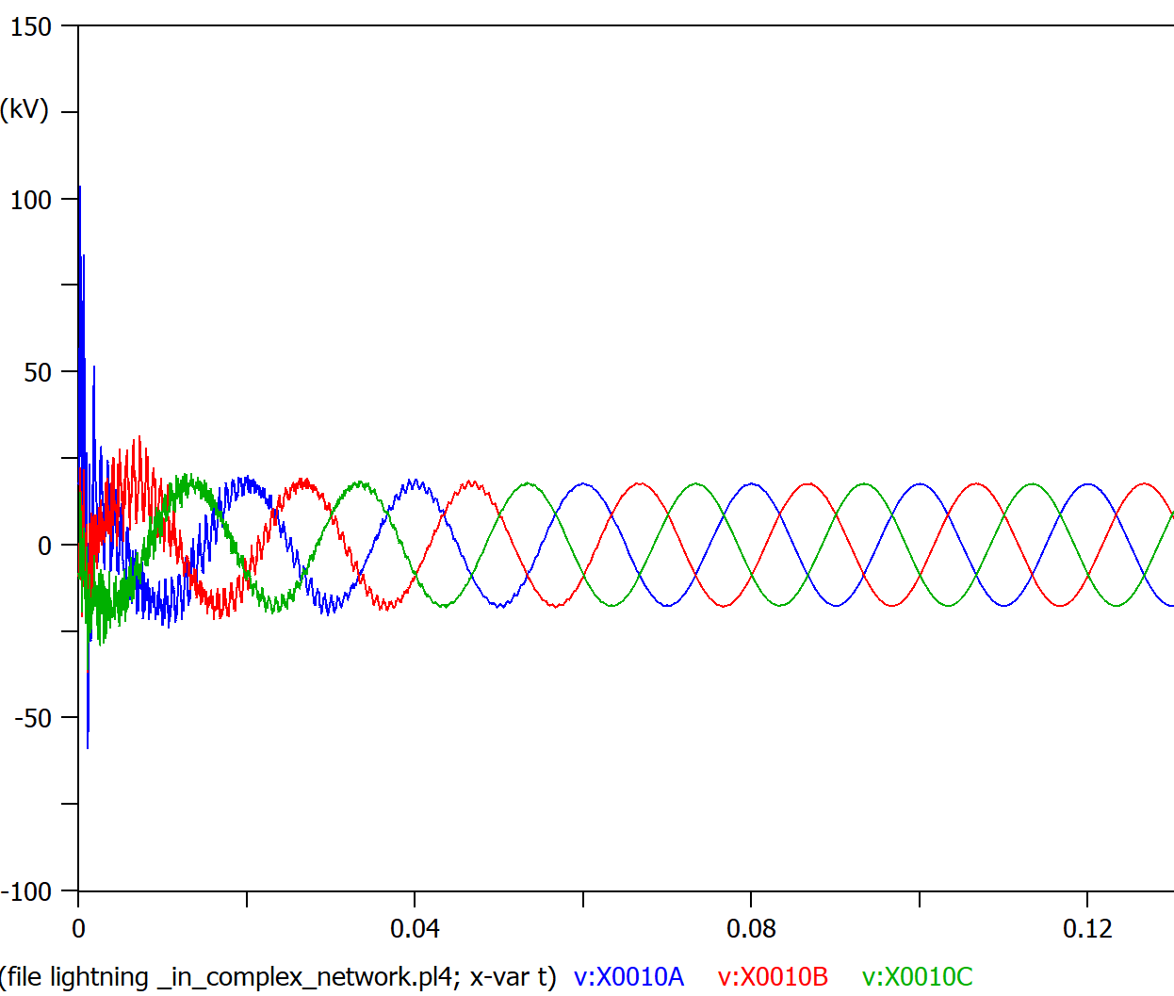

Figure overvoltage 100Kv<150Kv, isolation holds

7, right after transformer 2

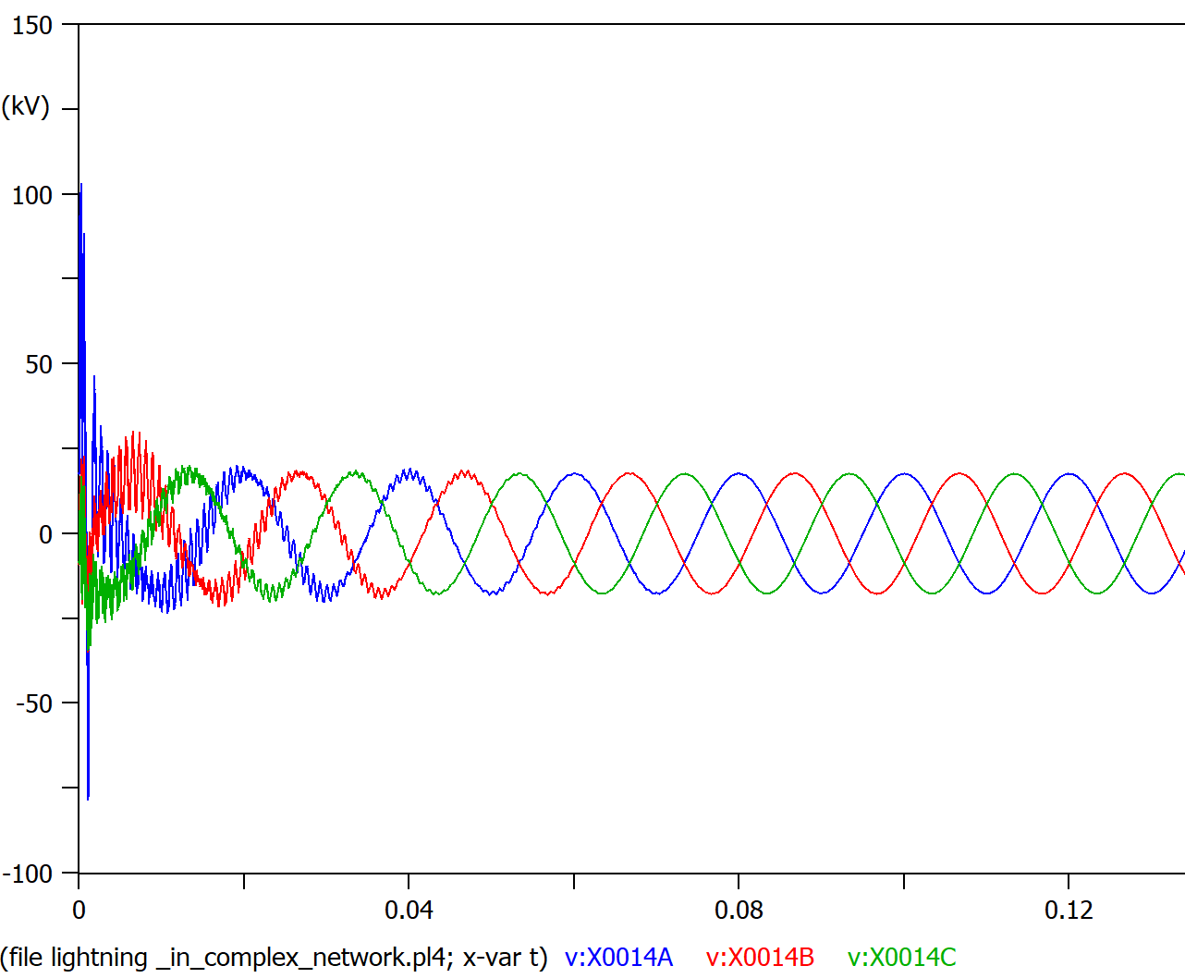

Figure overvoltage 110Kv<150Kv, isolation holds

8, after transformer 2, low voltage

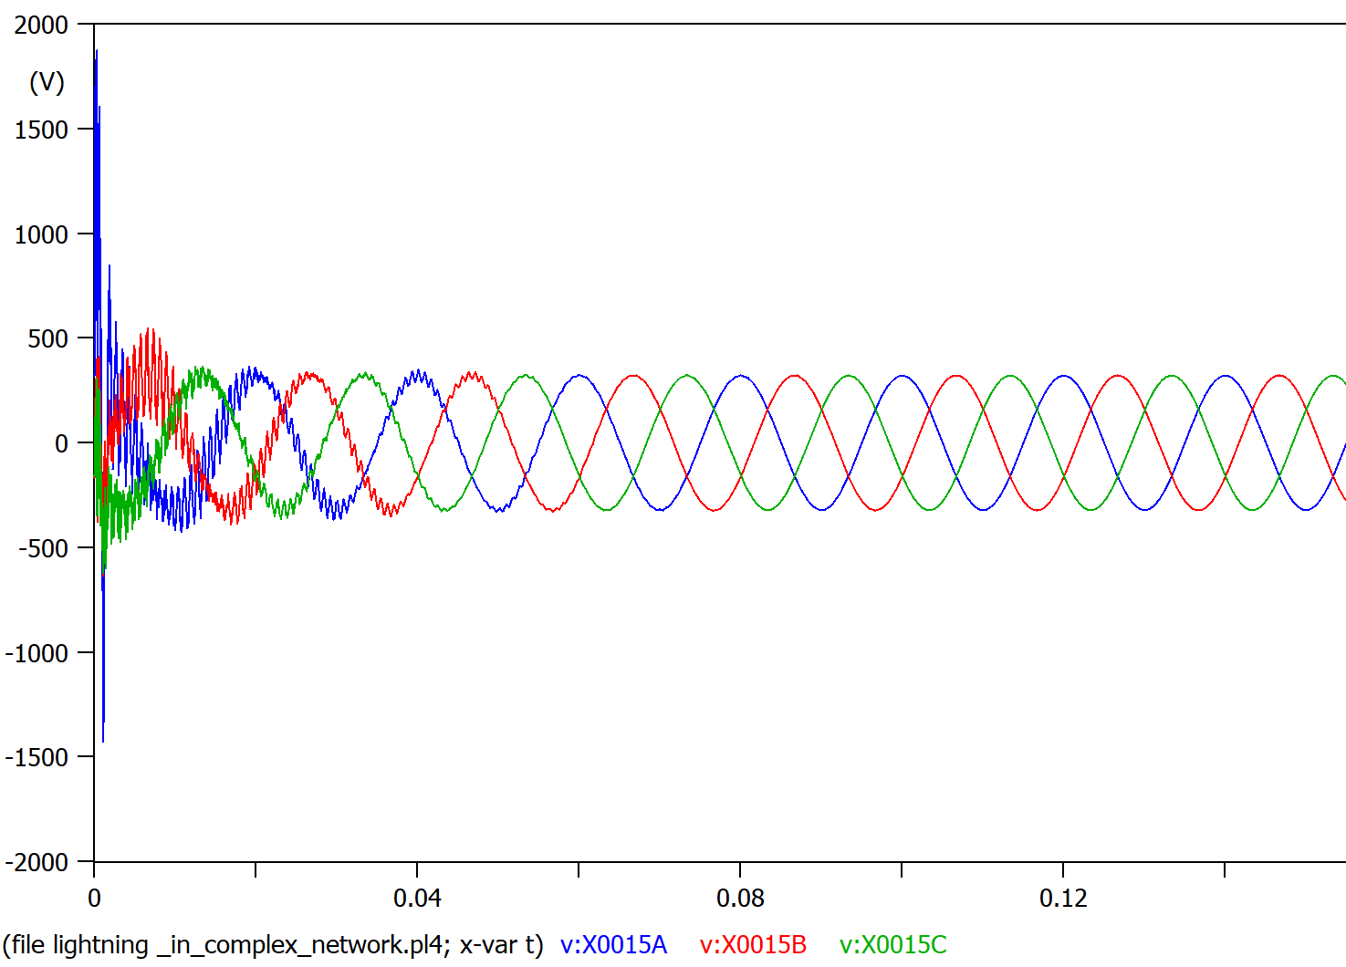

Figure overvoltage 2Kv<150Kv, isolation holds

Discuss the results.

The only effective way of guaranteeing the overvoltage from the lightning wont overcome the BIL, is to place a surge arrester as close as possible to our surge (in this case point 5)

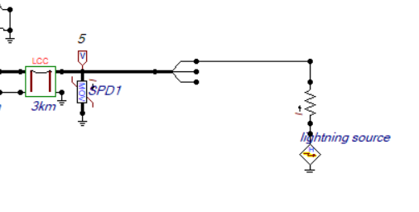

Figure , the only SPD “taking the current hit” is the one closer to the surge.

The rest of surge arresters are not activating, they are virtually not there at all.

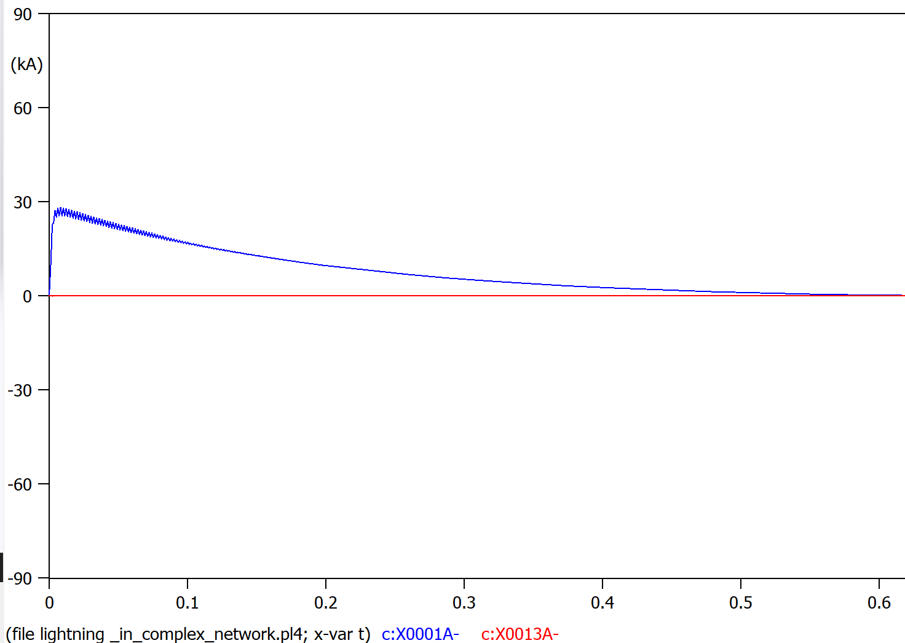

Figure 36, in blue the surge arrester at point 5 taking all the current, in red the next SPD at point 4

We don’t know where is the next lightning/surge going to hit exactly so we should place a SPD device on every different bus of our MV system.(figure 37)  
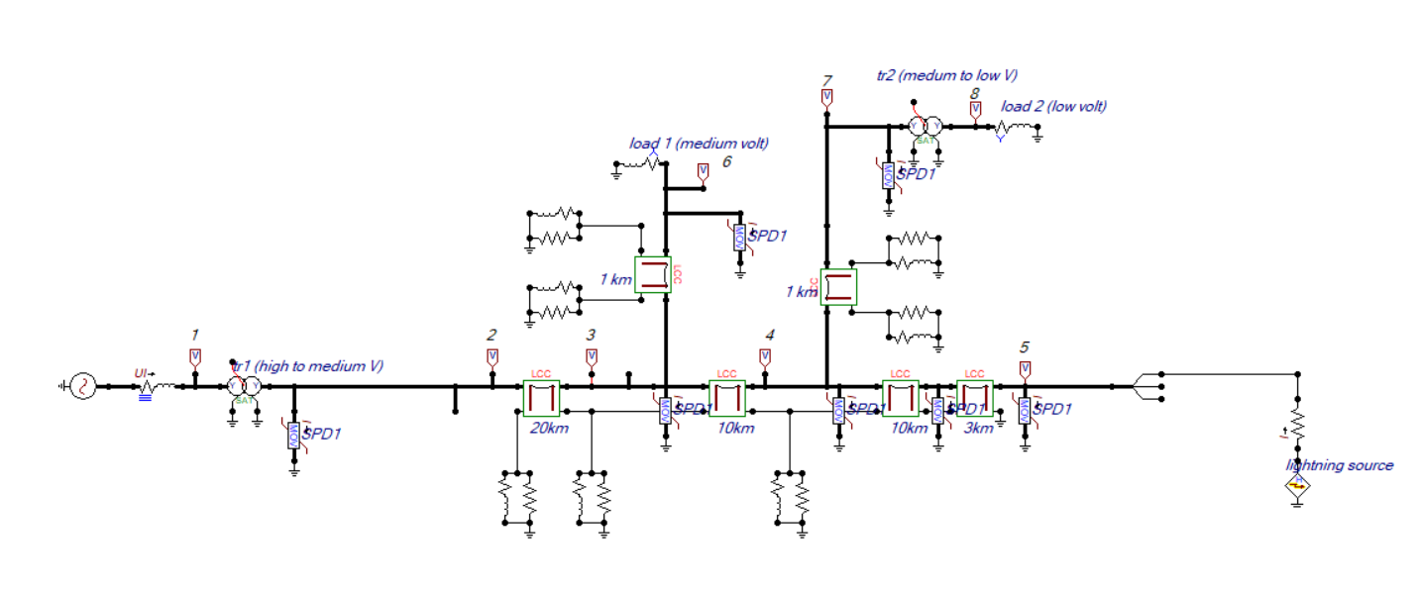

Figure , all MV buses with the corresponding surge arrester.

That would be enough for our exercise because our surge is hitting the MV network.  
But it could as well not be the case, surge arresters should be placed on the LV and HV sides of transformers also.

* For the **low voltage** lines, we could use a **I2R-T240-3P400** <https://www.transtector.com/ac-surge-protector-spd-i2r-t240-din-i2r-t240-3p400>
* For the **High voltage** lines , we could choose one of the **EXLIM — Porcelain-housed arresters from ABB’s catalog** <https://library.e.abb.com/public/f5bca70c527f7005c1257b130057b818/Surge%20Arrester%20Buyers%20Guide%20Edition%206.pdf>